Q.Explain the concept of a circular queue? How is it better than a linear queue?
Draw the queue structure in each case when the following operations are performed on an empty queue.
(a) Add A, B, C, D, E, F
(b) Delete two letters
(c) Add G
(d) Add H
(e) Delete four letters
(f) Add I

Sol:
Intial Queue.
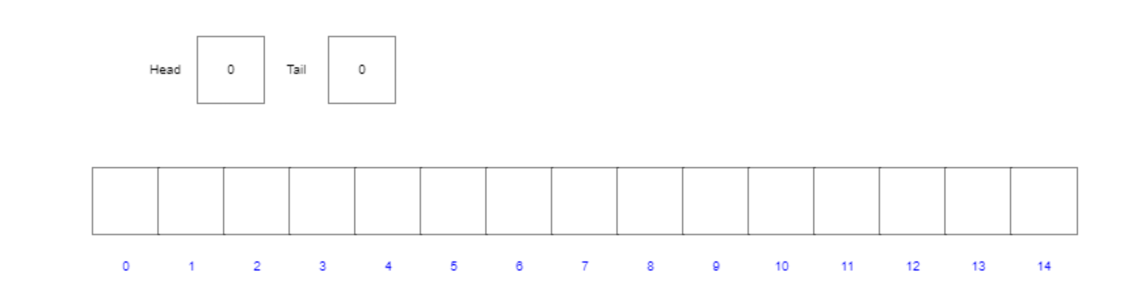

a.) Add A,B,C,D,E,F
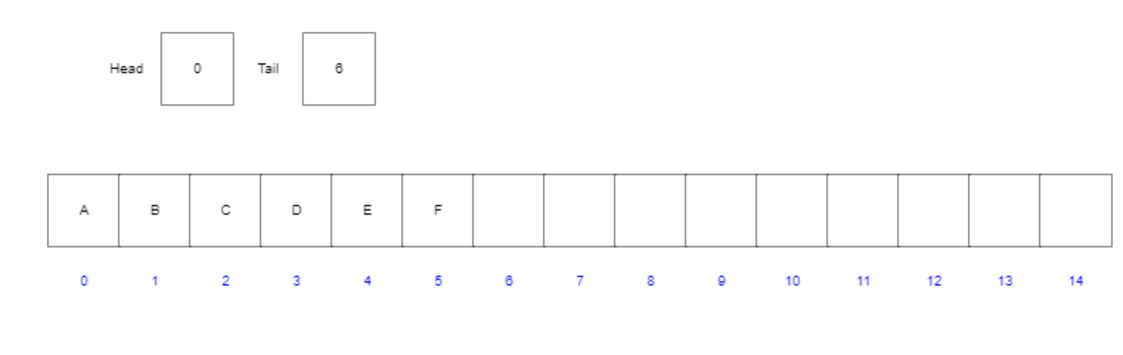

(b) Delete two letters
dequeuing A
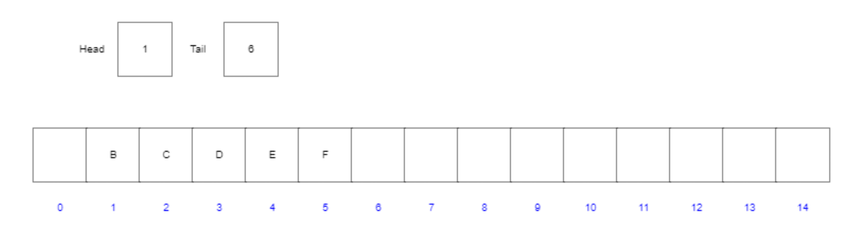

Dequeing B
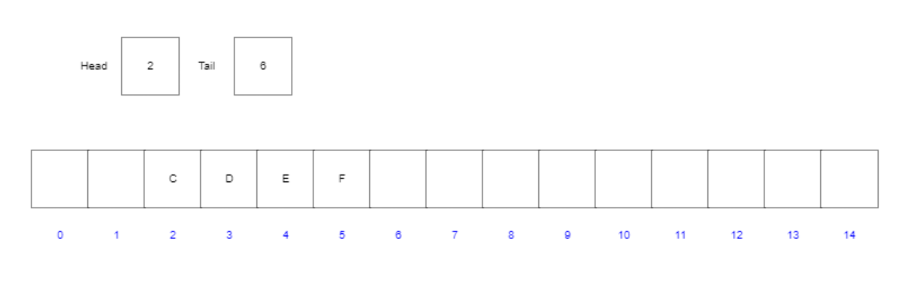\
(c) Add G
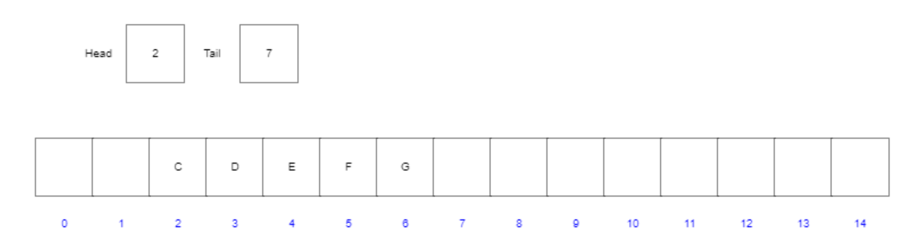

d) Add H
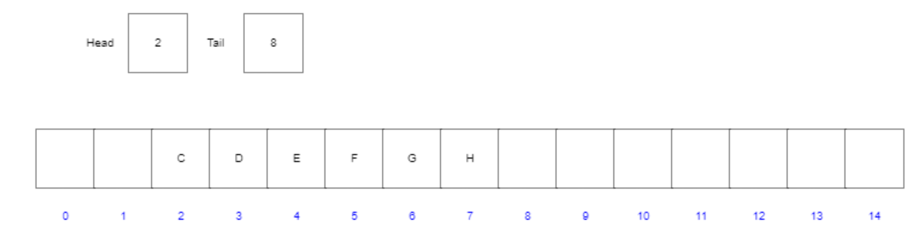

(e) Delete four letters
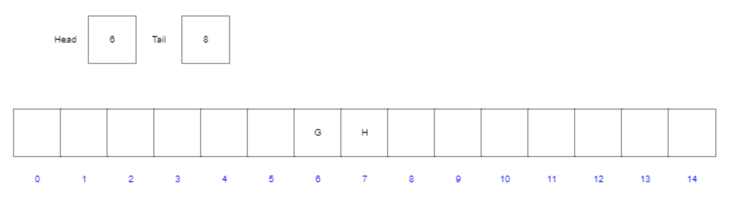

(f) Add I
