Create a trigger that checks if “value” is greater than 1000 for any new row inserted to “Test” table, then insert a row to Audit table?

CODE:
CREATE TABLE Test
(
test_id INTEGER,
value NUMBER,
test_date DATE
);
-------------------------------
CREATE TABLE Test_audit
(
test_id INTEGER,
value NUMBER,
test_date DATE
);

----------------------------------

CREATE TRIGGER trg_test
AFTER INSERT ON Test
FOR EACH ROW
WHEN (NEW.value > 1000)
BEGIN
INSERT INTO Test_audit
VALUES(:NEW.test_id, :NEW.value, :NEW.test_date);
END trg_test;

-------------------------------------
--- value <1000 (row get inserted to audit table also)
INSERT INTO Test VALUES (001, 2000, DATE '2021-02-01');

----------value >1000 (inserted only in test table)
INSERT INTO Test VALUES (002, 800, DATE '2021-03-06');

select * from Test
select * from Test_audit

OUTPUT:
INSERT INTO Test VALUES (001, 2000, DATE '2021-02-01');
--- value <1000 (row get inserted to audit table also)
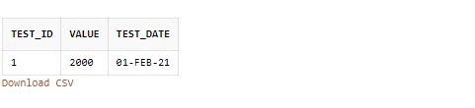
----------value >1000 (inserted only in test table)
INSERT INTO Test VALUES (002, 800, DATE '2021-03-06');
