------------DDL COMMANDS
----CREATE:
create table employee(
empno number,
ename varchar2(10),
job varchar2(10),
mgr number,
sal number);
-----DROP:
DROP TABLE EMPLOYEE

--ALTER
alter table employee rename column mgr to manager_no;
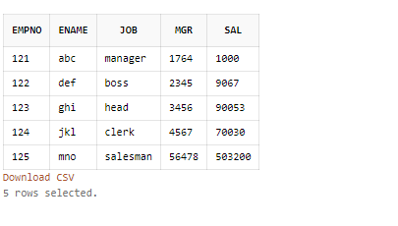

-----truncate table
truncate table employee;
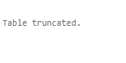

----------DML COMMANDS:
-----INSERT:
insert into employee values(121,'abc','manager',1764,1000);
insert into employee values(122,'def','boss',2345,9067);
insert into employee values(123,'ghi','head',3456,90053);
insert into employee values(124,'jkl','clerk',4567,70030);
insert into employee values(125,'mno','salesman',56478,503200);
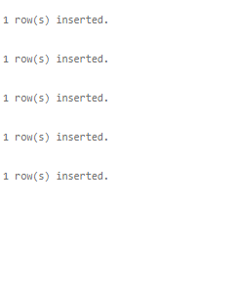
---UPDATE
select * from employee;
update employee set job='organizer' where empno=123;
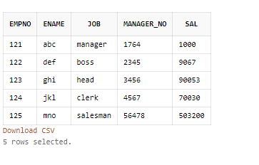

----DELETE
DELETE FROM EMPLOYEE WHERE EMPNO=121;

