Experiment-2.3

Student Name: UID:
Branch: BE-CSE Section/Group:814B
Semester: 4
Subject Name: Computer Network Lab

- Aim/Overview of the practical:
Configure a network using Static routing and Distance Vector routing Protocol using Packet Tracer.
- Task to be done/ Which logistics used:

Understand Routing Mechanism
- S/W Requirement:
Packet Tracer.

4. H/W Requirement:
- g. Celeron
- Main Memory - 128 MB RAM
- Hard Disk – minimum 20 GB IDE Hard Disk
- 44 MB Floppy Disk Drive

- Result/Output/Writing Summary:

a) Static Routing:
Static routing is the manual method of routing . In static routes the administrative distance is as default value. In Static routing, we can enter all the routes manually to the router. In other words, we can define each routing steps one by one. To access a network, which nodes we need to pass through, we can define such steps. This work is not an easy work, so static routing is used in small networks.

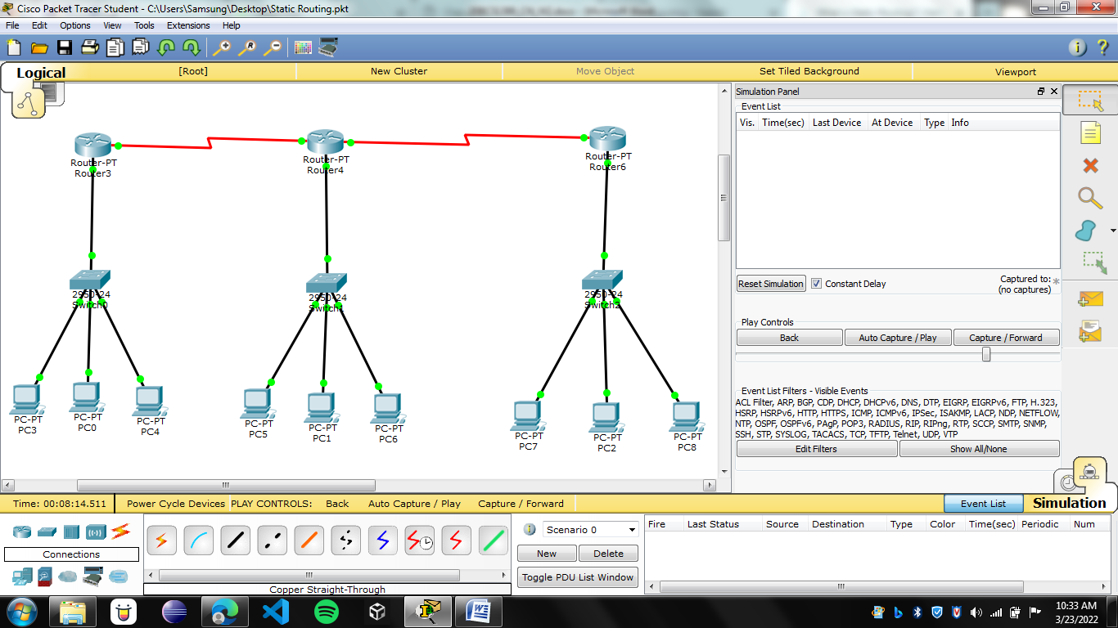

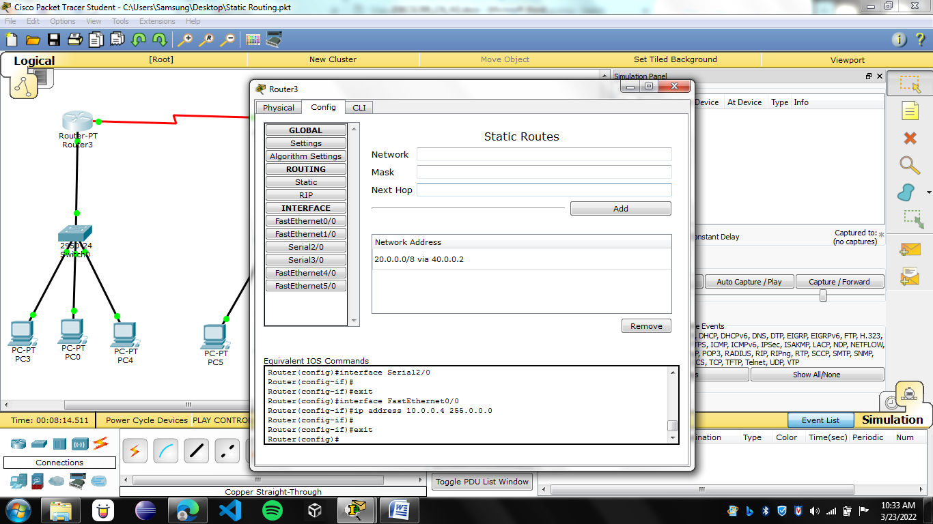
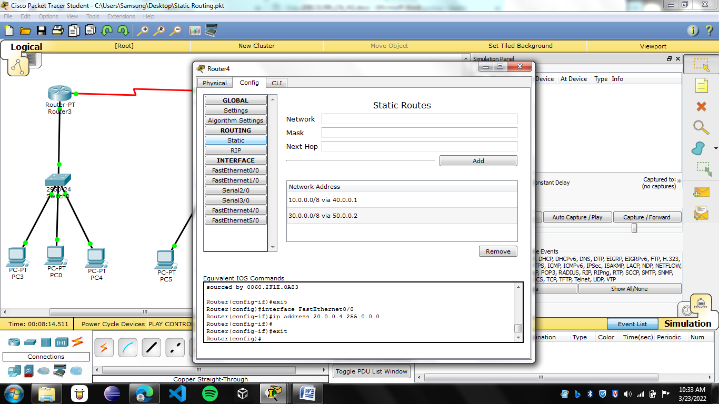

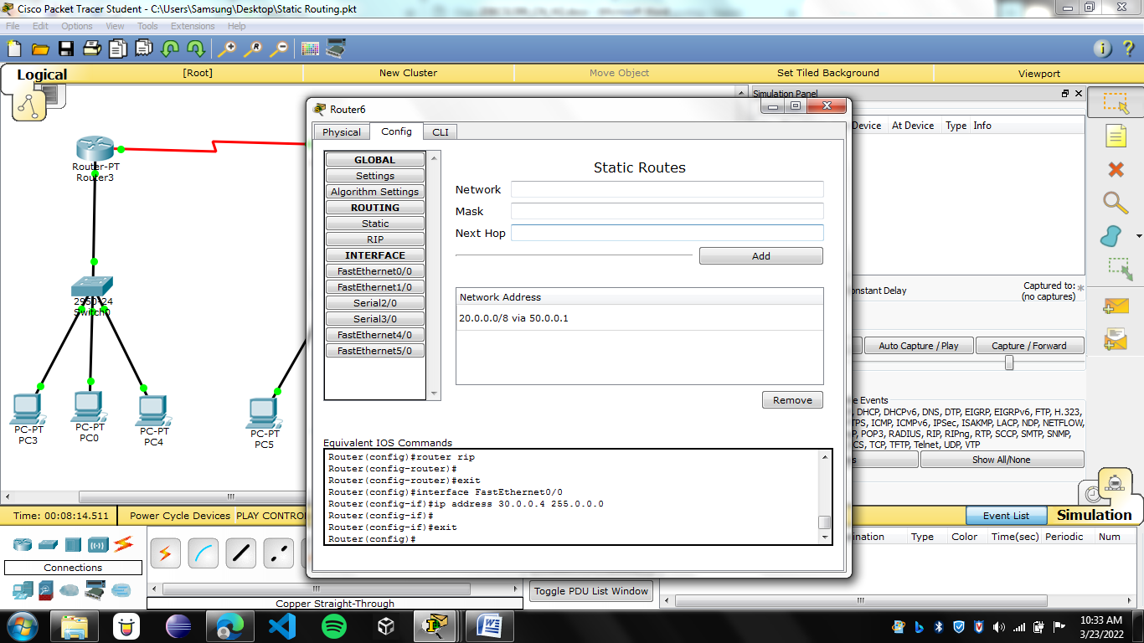

b) Dynamic Routing:
Dynamic routing is the routing that is done with the help of Routing Protocols. Dynamic Routing is a network routing procedure that facilitates the routers to pick and choose the routing paths depending on the network structure’s logical changes in real-time. This is opposite to the typical traditional static network routing. This is an automated routing technique that requires very less administration and supervision. Various protocols used in this routing method are Open Shortest Path First (OSPF), Routing Information Protocol (RIP), Border Gateway Protocol (BGP), and Enhanced Interior Gateway Routing Protocol (EIGRP).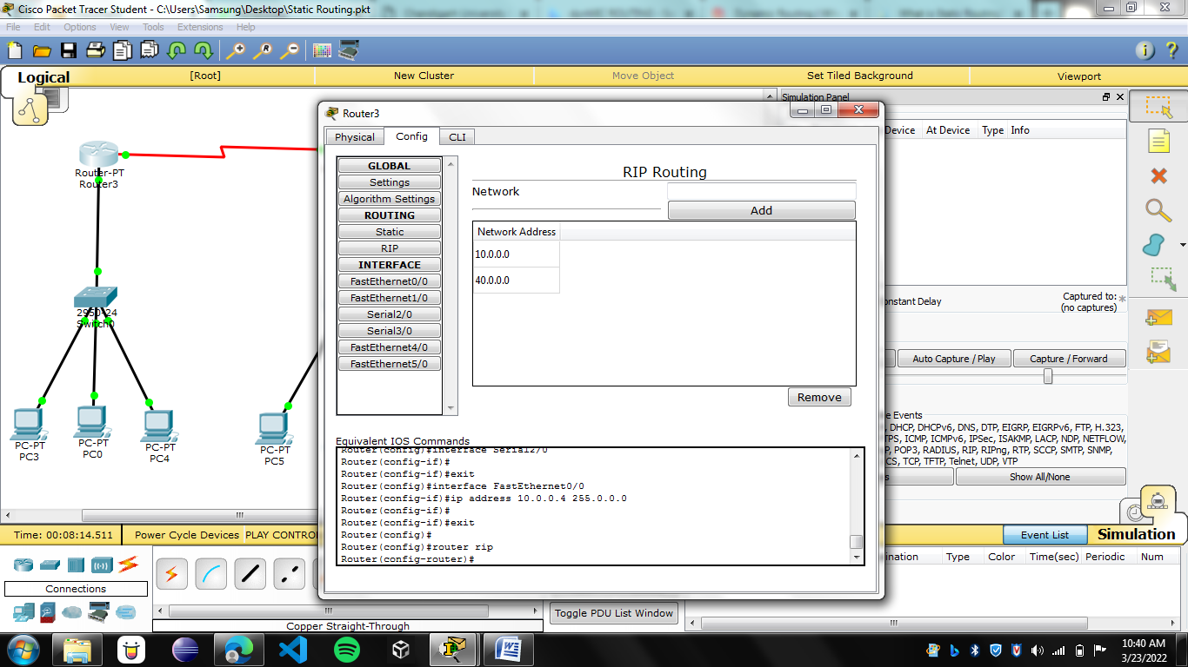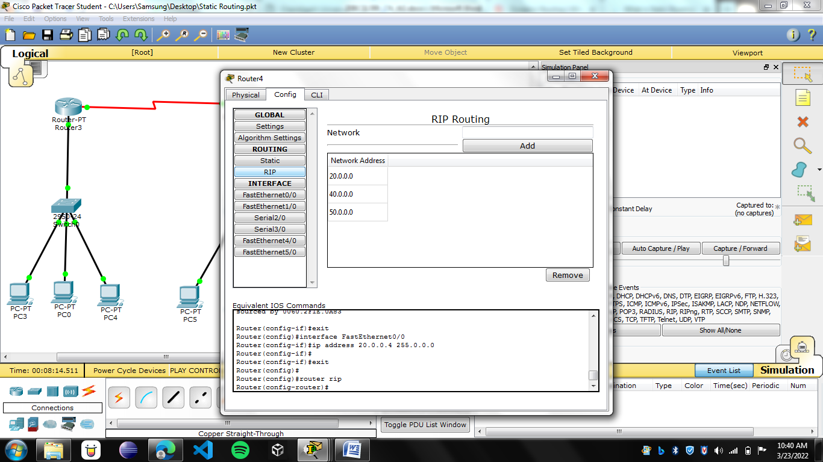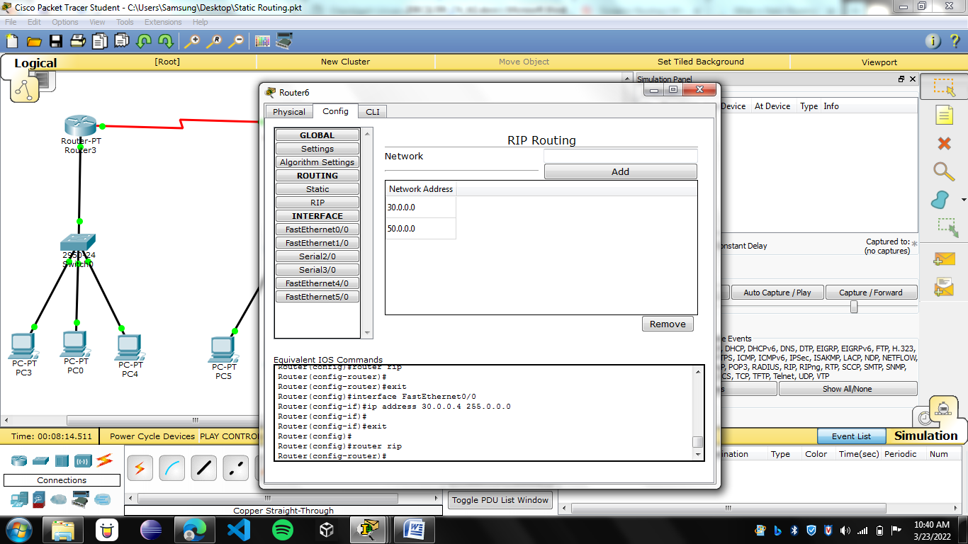

Complete Network:

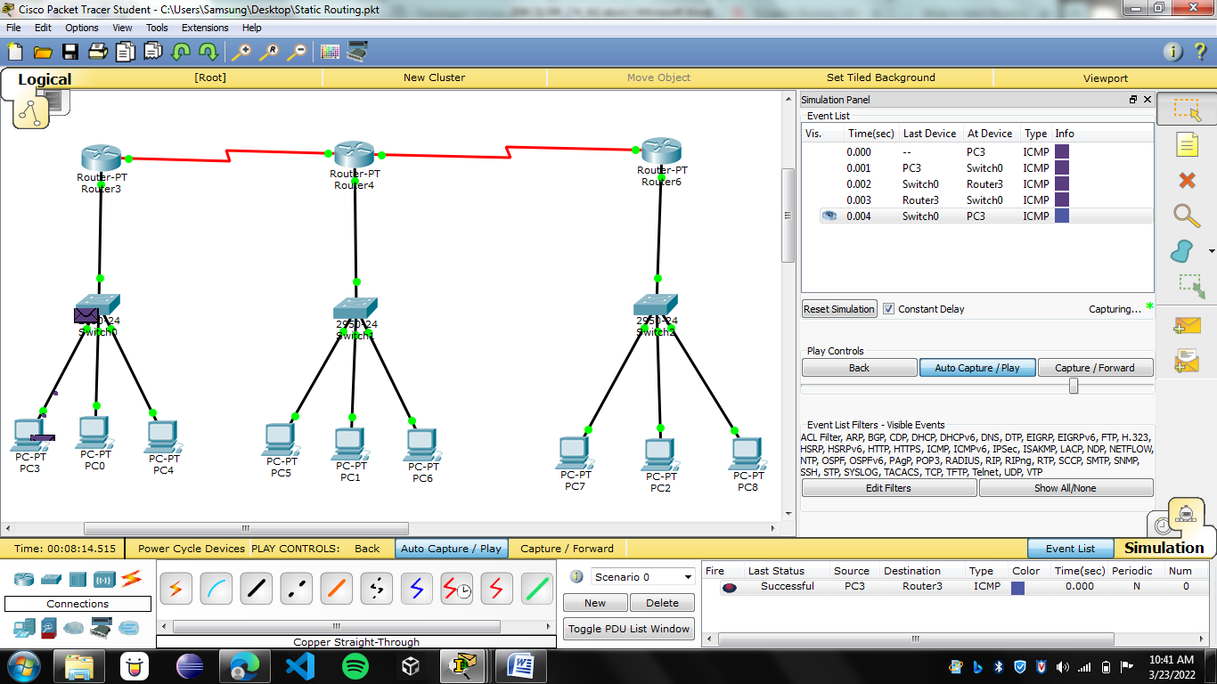
(Message Sent from Pc3 to router-3)
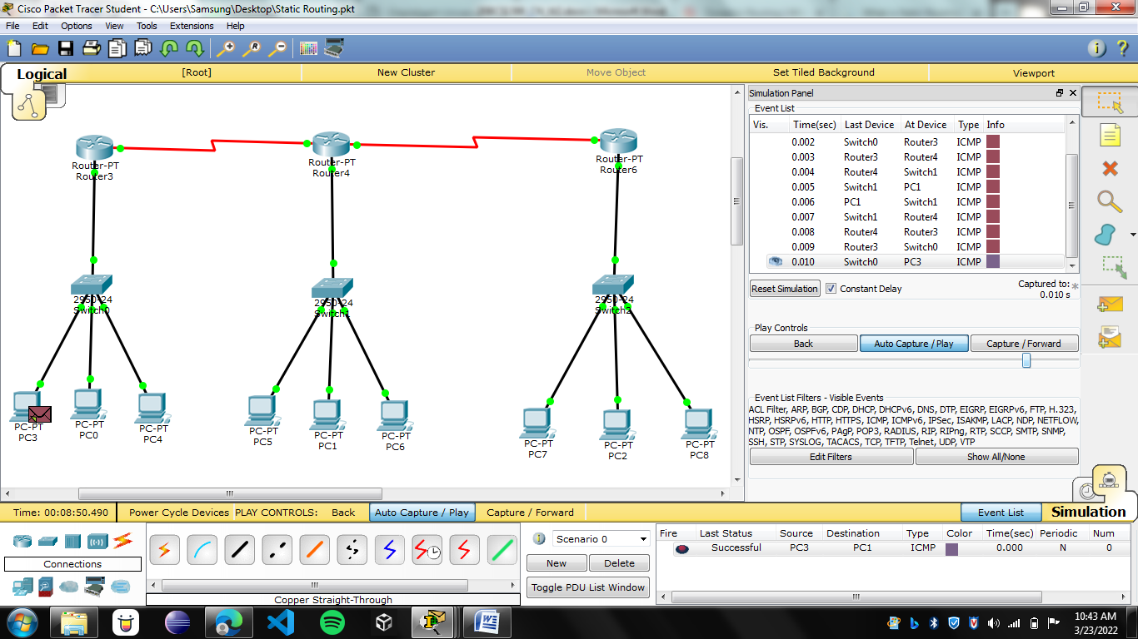
(Message sent from Pc-3 to Pc-1)
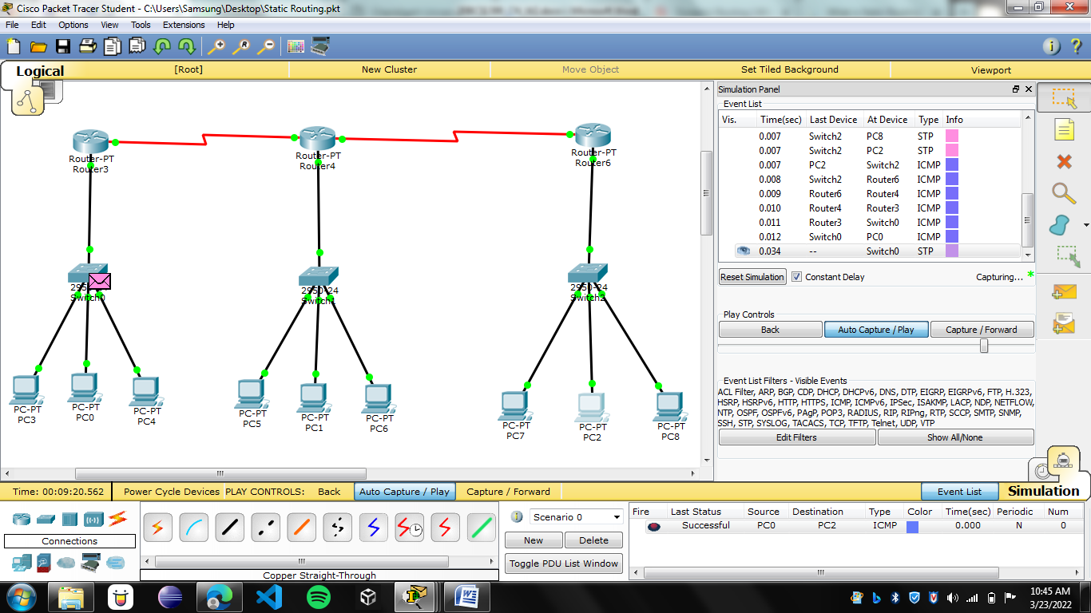
(Message Sent from PC-0 to Pc-2)

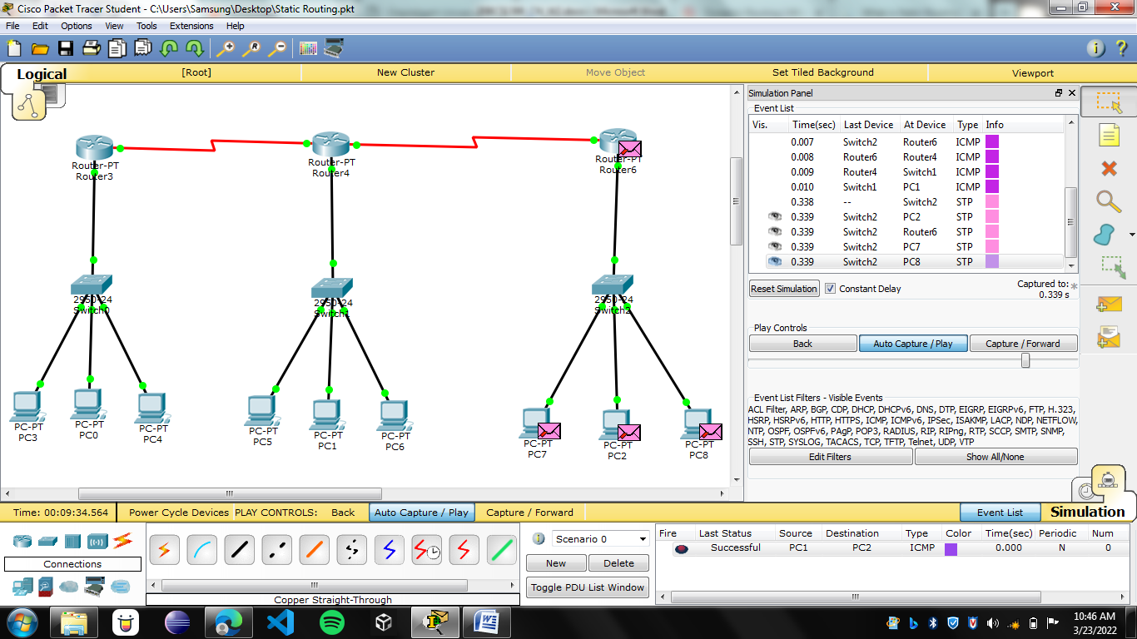
(Message sent from Pc-1 to Pc-2)

Learning outcomes (What I have learnt):
- Leant about Routing.
- Learnt how to configure network using static and dynamic routing.
- How to troubleshoot the network.
- Learnt to route the different networks.
1. : Troubleshooting of networks and devices

Evaluation Grid (To be created as per the SOP and Assessment guidelines by the faculty):
Sr. No. | Parameters | Marks Obtained | Maximum Marks
1.
2.
3.

