NAME:

AIM:
a)TO FIND THE SMALLEST OF TWO 8 BIT NUMBERS
b)TO Find the largest of two 8 bit no.

REQUIREMENTS: JUBIN SIMULATOR

CODE:

a)TO FIND THE SMALLEST OF TWO 8 BIT NUMBERS
LXI H,1000H
MOV A,M
INX H
MOV B,M
CMP B
JC 200BH // JUMP TO ADDRESS 200BH IF THERE IS NO CARRY
MOV A,B // MOVE THE SMALLLEST FROM REG. B TO REG. A
INX H // INCREMENT H-L PAIR
MOV M,A // MOVE RESULT REG A TO MEMORY
HLT

#ORG 1000H
#DB 30H,10H

b)TO Find the largest of two 8 bit no.

LXI H,1000H
MOV A,M
INX H
MOV B,M
CMP B
JNC 200BH // JUMP TO ADDRESS 200BH IF THERE IS NO CARRY
MOV A,B // MOVE THE LARGEST FROM REG. B TO REG. A
INX H // INCREMENT H-L PAIR
MOV M,A // MOVE RESULT REG A TO MEMORY
HLT

#ORG 1000H
#DB 30H,10H

OUTPUT:
a)TO FIND THE SMALLEST OF TWO 8 BIT NUMBERS
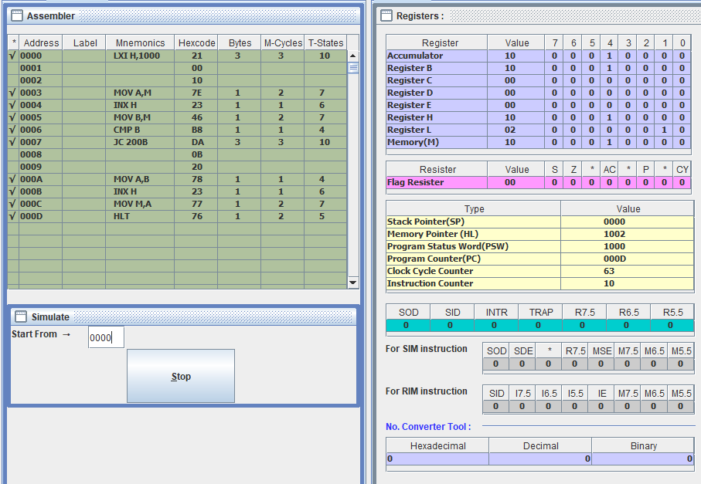
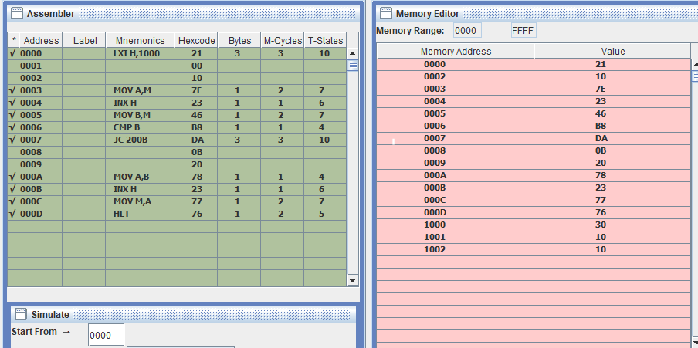

b)TO Find the largest of two 8 bit no.

