Name:

AIM:
a) Mask the lower nibble of an 8-bit number.
b) Mask the higher nibble of an 8-bit number.

Theory:
ANI is a mnemonic, which stands for “ANd Immediate with Accumulator”
This instruction is used to AND 8-bit immediate data with the Accumulator’s content.

A | B | A AND B = C
0 | 0 | 0
0 | 1 | 0
1 | 0 | 0
1 | 1 | 1

CODE:
Mask the lower nibble of an 8-bit number.

LDA 2000H
ANI F0H
STA 2001H
HLT

#ORG 2000H
#DB 15H

Mask the higher nibble of an 8-bit number.
LDA 2000H
ANI 0FH
STA 2001H
HLT

#ORG 2000H
#DB 15H

OUTPUT:

Mask the lower nibble of an 8-bit number.

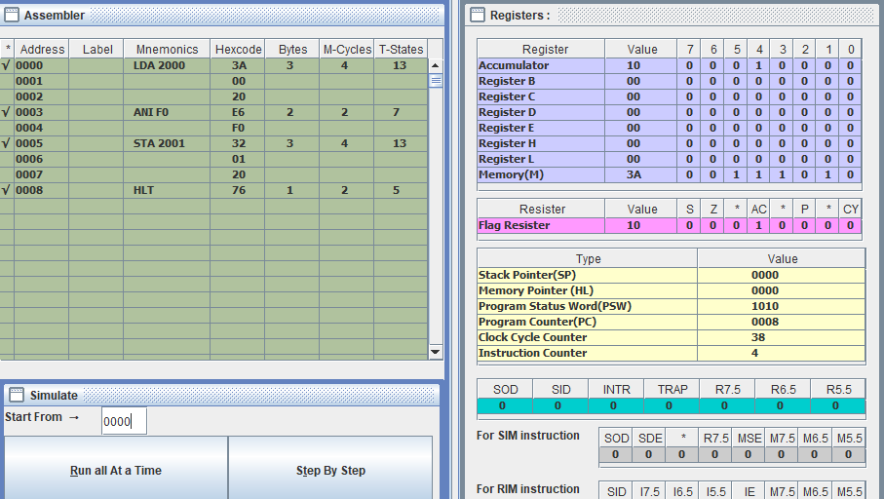
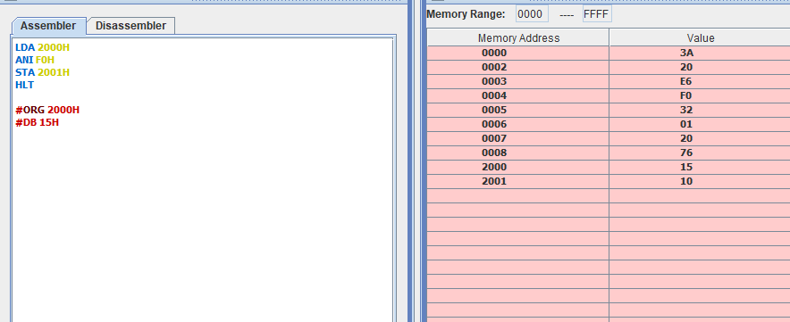

Mask the higher nibble of an 8-bit number.
